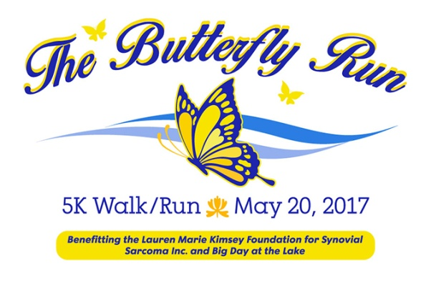

Dear Sponsor,

Thank you for considering a sponsorship to support the inaugural Butterfly Run 5K benefitting “The Lauren Marie Kimsey Foundation for Synovial Sarcoma, Inc.” and “Big Day at the Lake”. Our dear friend and colleague, Lauren Kimsey, was a big supporter of Big Day at the Lake, so what better way to help cancer research and Lauren’s favorite charity in one event!

Lauren’s fight began six years ago, when a small lump appeared on her arm. The initial diagnosis was a pulled muscle from exercise – as Lauren was very physically active, fit and the picture of health. After months of physical therapy with no relief, it was discovered that Lauren had synovial sarcoma – a rare soft tissue cancer with no known cure. The exact underlying cause of synovial sarcoma is poorly understood and it is the families wish to help find the cause and cure. After a fight like no other, this terrible disease took her on September 10, 2016….just months shy of her 40th birthday. In honor of Lauren, the “Lauren Marie Kimsey Foundation for Synovial Sarcoma, Inc.” was formed.

As a sponsor, you have the opportunity to help find a cure for this terrible disease and also to help the lives of young people in the Big Brothers/Big Sisters organization. We hope you will review the attached sponsorship levels and benefits and join us in making a difference.

Sincerely,

Laura Engel

Race Director

Butterfly Run