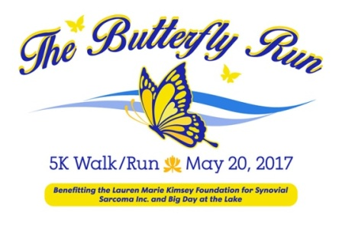

**2017 5K Sponsorship Agreement**

Name of Organization: 

Address:  City/Zip Code: 

Website: 

Owner/Contact: 

Email/Phone Number: 

Yes, we would like to become a 2017 Butterfly Run event sponsor

Sponsorship Level 

Yes, we would like to become an in-kind sponsor. We would like to offer as an in-kind sponsorship.

No, but we would like to make a tax deductible donation to

The Lauren Marie Kimsey Foundation for Synovial Sarcoma, Inc. (501(c)(3) status – applied for)

In the amount of $  (Tax ID Number 81-4645722)

Big Day at the Lake

In the amount of $  (Tax ID Number 56-2264009)

No, but for $50 we would like to include our promotional items in the race goody bags

We understand and agree that in order to become a Butterfly Run event sponsor and to be part of promotional opportunities, our sponsorship funds and digital company logo must be provided by April 30th to Race Director Laura Engel (see contact information below). All promotional items must be provided by May 17th to be included in race bags. Logo for t shirts must be provided by May 1st .



Sponsor Signature Date

**PLEASE RETURN THIS FORM TO:**

Laura Engel

AQUESTA BANK, 19510 Jetton Road, Cornelius, NC 28031 704-439-1409/email: [lengel@aquestabank.com](mailto:lengel@aquestabank.com)